Max Tree

XO-NANO Smartfoam

1/27/22

Single Sensor Demo Instructions

**Introduction**

This instruction sheet walks through the set up required for a single XO-NANO pressure sensor demonstration as seen in Fig. 1. This demonstration of the sensor shows how the root-mean-square of the voltage (Vrms) changes with pressure. This instruction sheet shows steps for setting up pressure sensing with an Analog Discovery 2 (AD2) and an Arduino Uno; but, other data acquisition and signal generation devices can be used. If you choose to use your own waveform generator and ADC, follow the schematic in Fig. 2 and use the settings listed in the instructions found in the AD2 instructions section.

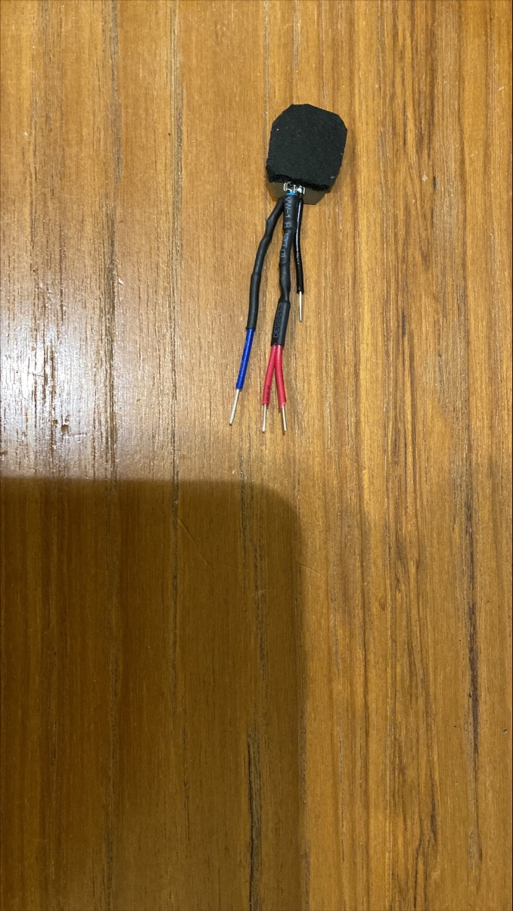

Figure . 0.5”x0.5” XO-NANO Pressure Sensor for demonstration purposes. The black wire is GND, the blue wire is for the negative analog input (AI-), and the two red wires are for a PWM (or sine wave) and the positive analog input (AI+).

Figure Generalized schematic for those not using an AD2. For the best results, have the Waveform Generator and the ADC on the same clock.

The advantage of the AD2 is that it allows the user more freedom to try various different kinds of input signals and its program automatically calculates Vrms. Another benefit of the AD2 is its high quality ADC. The advantage of the Arduino Uno is its price; however, the Arduino Uno is not as refined as the AD2 and produces a lower quality output. Regardless of the electronics used to generate and process the signal from an XO-NANO pressure sensor, output data will visually show that pressure and output voltage are correlated.

**AD2 Instructions**

1. Purchase an [AD2](https://digilent.com/reference/test-and-measurement/analog-discovery-2/start).
2. Download and install [Waveforms](https://digilent.com/shop/software/digilent-waveforms/download).
3. Plug in the AD2 to the computer.
4. Open Waveforms.
5. From the Waveform’s welcome page, click on the Wavegen button and set up Wavegen 1 (waveform generator) to the desired signal (Example: 1kHz square wave with 2.5V offset and 2.5V amplitude or, in other words, a 5V PWM) as seen in Fig. 2. NOTE: square waves and sine waves work the best for this sensor. Feel free to adjust the amplitude between 1V-5V, the wave frequency (500Hz-10kHz), the sampling frequency, and the offset. The sensor should still react to pressure for a wide range of these input values.

Figure . 5V amplitude PWM set up in the AD2's Wavegen 1.

1. From the welcome page, click the logger function and have the C1 True RMS visible (Fig. 3). NOTE: I left the update pull down at 1s (this pull down controls the sampling frequency).

Figure . AD2 Logger Function set up to display C1 True RMS only (blue). In this example, the sensor was left alone for 35 seconds, then a small pressure was applied for 4 seconds with my thumb, then I increased the pressure for 4 seconds and then I released all pressure.

1. Fix the sensor’s position to avoid undesirable output voltage (Fig. 4).

Figure . 0.5"x0.5" XO-NANO pressure sensor fixed to a flat slab of wood with electric tape to prevent the senor from moving.

1. Attach the sensor to the appropriate wires of the AD2 (Fig. 5). The color of the AD2 wires can be followed and double checked with the small symbols written on the AD2 (Fig. 6) For an AD2, attach the following:

* a black AD2 wire ( ) to the black wire of the sensor
* the solid yellow wire (W1) to either of the red wires of the sensor
* the solid orange wire (1+) to the other red wire
* the orange wire with a white stripe (1-) to the sensor’s blue wire.

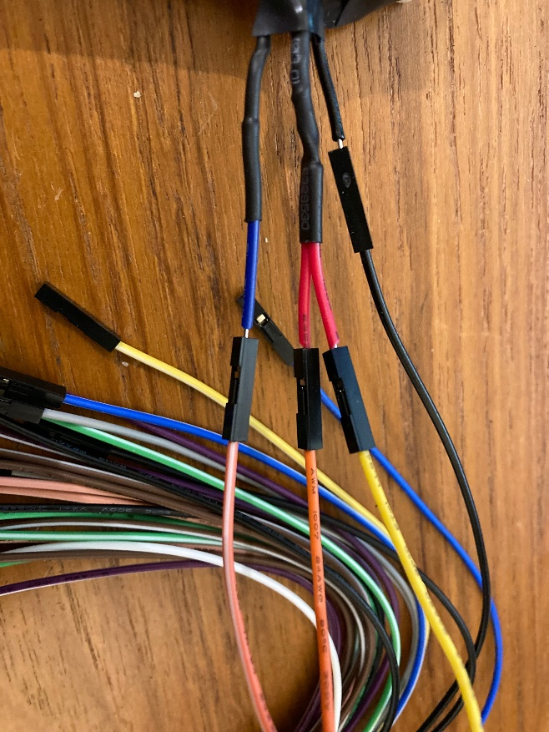

Figure . Wire connections for the AD2 to the sensor.

Figure . Small symbols that represent different leads to the AD2.

1. Start the Waveform generator by clicking the green play button in the wavegen window.
2. Start the logger by clicking the green play button in the logger window. Adjust the window size by clicking on the small gear button associated with C1 True RMS. The example in Fig. 3 was set to have a window size of 200mV. The window location depends on the input signal used. NOTE: Ensure that the C1 True RMS is dictating the graph on the screen by clicking on the “Name” box of C1 True RMS to highlight its row (the row will highlight blue or light grey). This was done correctly if the numbers on the y-axis are blue/match the color of the logger signal.
3. Apply pressure to the foam sensor and watch the change in Vrms in the logger window as you apply different pressures. An example is seen in Fig. 3. In the example, a maximum change of about 20mV was produced with my thumb.

**Arduino Uno Instructions**

1. Purchase an [Arduino Uno](https://store-usa.arduino.cc/collections/boards/products/arduino-uno-rev3-smd).
2. Download and install an Arduino IDE. For windows, go to your Microsoft Store and search “Arduino IDE.” Then download the program with the Arduino logo (see Fig. 8)

Figure 8 Arduino IDE App. Screen shot taken of the app in the Microsoft Store.

1. Assemble Arduino Uno and XO-NANO Pressure Sensor as seen in Fig. 9 and 10. Note that the LED part of the circuit is extra and not necessary for the visualization of pressure. Also note the cable in Fig. 10 that increases the sensor’s sensitivity when using an Arduino.

Figure 9 Schematic of the XO-NANO Pressure Sensor-Arduino Uno interface. An extra circuit of LEDs is also included. Each LED lights up when pressure reaches a certain threshold (see code). Image was generated using tinerkcad.com. The LED in the schematic is an RGB LED.

Figure 10 Arduino adapter cable. Plug this into either red pin from the XO-NANO sensor and then plug the other end of the cable into the Arduino Uno's PWM pin (pin 9).

1. Connect the Arduino Uno to a computer via USB.
2. Open the Arduino IDE.
3. Go to XO-NANO’s [Dev-kit-resource github page](https://github.com/XOnanoSmartfoam/Dev-Kit-Resources/blob/main/StreamPressureData.ino) and copy “StreamVoltageData.ino” and paste it into a new script.
4. Save the file as “StreamVoltageData” in a desired location.
5. Select the port in which the Arduino Uno is plugged in. NOTE: if the board is not automatically detected, select the board in the drop down right above the Port drop down (Fig. 11).

Figure 11 Screenshot showing where to select the port and board settings in the Arduino IDE.

1. Upload the file onto the Arduino Uno (See Fig. 12)

Figure 12 The upload button is located in the upper left and corner. In this screen shot, it is the circular button with an arrow that is highlighted white.

1. Once the program has been uploaded, activate either the Serial Plotter or Serial Monitor tools found in the Tools tab (See Fig. 11). Both the Serial Plotter and Monitor tools will open a separate window where the data will be output. At the bottom of the new window is a Baud Rate selector. Make sure this number matches that of the code (9600) or you will not see the data.
2. Secure the XO-NANO Pressure sensor (Fig. 5).
3. Press on the XO-NANO sensor to see its reaction in the Serial Plotter, Serial Monitor, or the LEDs (if you did the extra LED set up). Example data is seen in Figures 13 and 14.

Figure 13 Example of data stream in the Serial Plotter tool. The first 50 seconds is the system warming up and should be ignored. The first peak is when my finger first touched the XO-NANO pressure sensor and the distance beneath the original steady state is the n

Figure From zero pressure to pushing with my finger. Note that steady state in both cases has a small wave.

NOTE: Due to the Arduino’s ADC being plugged into the AI- pin of the XO-NANO Pressure Sensor, an increase in pressure will cause a decrease in Vrms (the opposite direction of the AD2).

NOTE: if you did the LEDs, you will have to manually adjust the LED pressure thresholds to determine when they will turn on.

NOTE: The Arduino Serial Plotter automatically zooms to fit all the data on the screen. Wait until large changes in voltage exits the screen to the left and the plotter will automatically zoom in.

**Troubleshoot Tips**

1. If the pressure sensor only seems to react to your finger and not inanimate objects, check GND connections.
2. If the reaction of the pressure sensor to pressure produces large waves (larger than those of steady state in Figure 13) or is random, then it is likely that one of the connections on the XO-NANO sensor needs to be repaired. This is an indicator for the AD2, Arduino Uno, and other forms of measurement.
3. When in doubt, double check the schematic.